Experiment No: 02
Experiment Name: Implement the Popular Image Enhancement Technique: Convert into Negative Image
Objectives:
- To understand the concept of image enhancement.
- To learn about negative image transformation.
- To implement image negative conversion using Python.
- To analyze pixel intensity transformation in digital images.
- To gain practical knowledge of image processing techniques.
Theory:
Image enhancement is a technique used to improve the visual appearance of an image or to extract important information from it. One common enhancement method is the negative image transformation.
In a negative image, the brightness values of the pixels are inverted. Dark regions become bright, and bright regions become dark. This transformation is especially useful in medical imaging, photographic processing, and satellite image analysis.
The negative transformation formula for a grayscale image is:
S=255−R
Where:
R = Original pixel intensity
S = Negative pixel intensity
For an 8-bit image, pixel values range from 0 to 255.
Code:
from PIL import Image
import matplotlib.pyplot as plt
import numpy as np

img = Image.open("sm_pic.jpg")
gray_img = img.convert("L")
img_array = np.array(gray_img)
negative_img = 255 - img_array
plt.figure(figsize=(10,5))
plt.subplot(1,2,1)
plt.imshow(gray_img, cmap='gray')
plt.title("Original Grayscale Image")
plt.subplot(1,2,2)
plt.imshow(negative_img, cmap='gray')
plt.title("Negative Image")
print(negative_img)
plt.show()
Output:
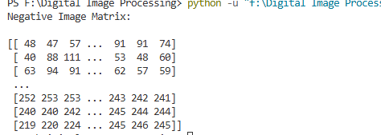
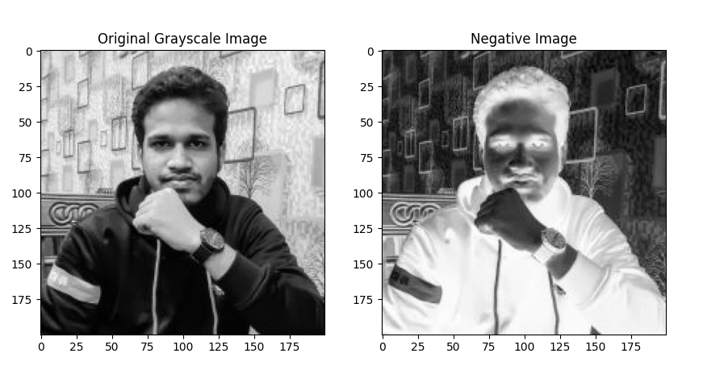
Result and Discussion:
In this experiment, a grayscale image was transformed into its negative form using Python. The negative transformation inverted the intensity values of each pixel successfully. This enhancement technique helps highlight hidden details in images and improves visual interpretation in various applications such as medical diagnosis and satellite imaging.
The experiment provided practical knowledge about image enhancement and pixel intensity transformation in digital image processing.

